REGISTRATION NOW OPEN
200 Hour Teacher Training exclusive at
Ananta Yoga Studio 2019-2020 Class
Get certified and evolve your own practice with a top Yoga School for the most comprehensive teachings of the key facets of Yoga. Creative styles of Yoga are learned, rooted in the solid foundation of alignment oriented yoga, anatomy, history and philosophies of Yoga, infused with Chakra system based energy learning.
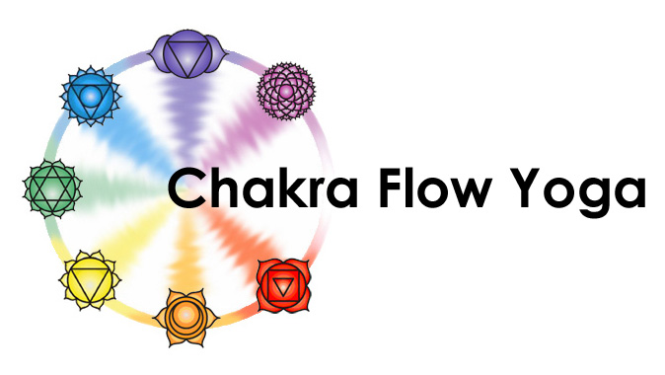 | 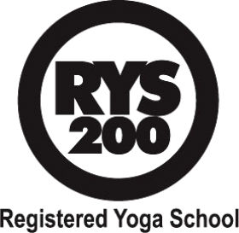
t
This comprehensive course includes:  - History and Philosophy of Yoga  - Theory and Practice of Asanas (poses), Mudras, and Pranayama.  - Anatomy and physiology, including energy anatomy and Chakras  - Therapeutic applications of Yoga and Mechanics of Yoga Anatomy  - Basics of Ayurveda, yogic lifestyle and diet  - Raja Yoga and Meditation  - Sanskrit of yoga postures and Mantras/chants.  - Restorative yoga and stress management  - Assisting, adjustments, and modification of poses, use of props  - Creative class sequencing and planning  - Practice teaching  - Enhancing self practice and well being  - Discount off yoga classes at Ananta Yoga Studio during the training timeframe | Training Schedule:  The course will start in the October months and spans 11 weekends over 10 months. (dates collaborated with trainees)  Graduation is in the June 2020.  In addition to in-class study, the participants will be required to do regular self-study, homework, reading and practice teaching. An on-going personal yoga practice is required.  Course Fees*:  $2900 for early registration by Oct 1th t (paid in full)  $3000 for registration by Oct 12st (paid in full)  $3200 after Oct 12st :  -$200 deposit due at time of registration  -$3000 balance due at the beginning of the program  -Payment plans are available  *A $200 non-refundable deposit is waived if the full payment is made at the time of registration.
All participants who complete the full course will receive a Certificate of Completion. This course is registered with The Yoga Alliance at the 200 hour level, so that graduates can become RYT (Registered Yoga Teachers).

The faculty: Ana Sorce, E-RYT500, Antonette Redl, E-RYT500, Lori Speizer, Director/Studio Owner/RYT200
Visit www.wayneyoga.com and submit your application today!

